Code Review 3: Netlogo Lassa Fever Spread Simulation

Daniel McDonough, 4/24

# Introduction:

This code review was done with code from Anne Le. Anne is writing a simulation for Lassa Fever Spread in Nigeria, in Netlogo. The following review discusses the behavior of her people and the spread.

# Code Review:

Figure 1 shows the functionality of the simulations turtles (or people) and does not currently compile due to the calls not being able to be made in observer view. The people are meant to move, eat and bread based on variables of energy and time that decrease and increase on consumption. However the calls are not made in a scope that allows proper execution of the commands. A proper fix is noted in Figure 2. Another point is to separate the observer, patch, and agent functions.

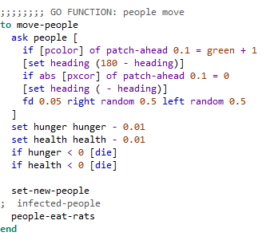

Figure : People Movement Behavior Error

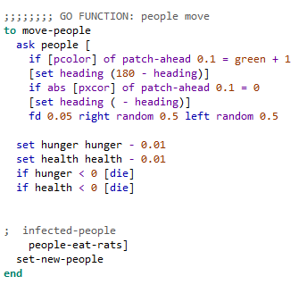

Figure 2: People Movement Behavior Fix.

# Discussion and suggestions:

Upon review of this code, I would highly suggest changing the position variables of the agents from patch distinction to the position variable of the agents themselves. This is a huge issue when changing the visual perspective of many of the agents. Another thing to change is to change the size of the area the simulation is in as it is way too big and hard to follow what goes on.